# A blue and red background Description automatically generatedautocompletes

Universal Search API

Autocompletes Load Test Results

# Testing

* **Unit Testing**
  + To ensure the autocompletes work properly prior to any new changes - Unit test cases are integrated with deployment pipeline, and it is restricted to have all the unit test cases to pass before deploying any new changes.



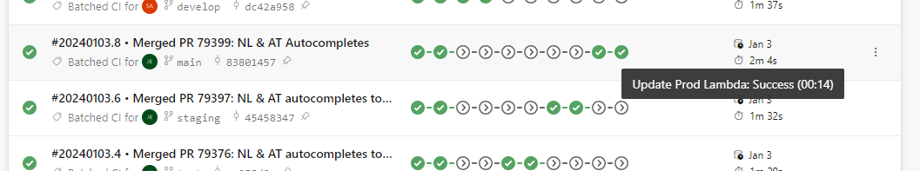

* **Regression Testing** 
  + A reference set run with 36K records iterating through each input character at random interval is used to test the autocompletes trying to simulate the real time usage.

* + The result of above run is positive with not much load on current infra/OpenSearch

* **Load Testing**
  + The current usage load of autocompletes for SE for a month and day metrics were captured from usage analytics.

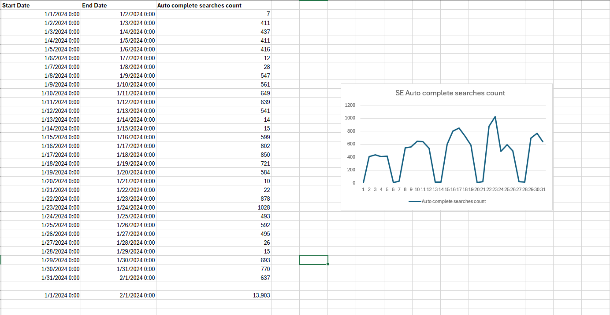

* + An API bulk trigger with a load of 1000 users are triggered to observe the performance which is way higher than the normal usage as per above statistics and all the requests are successful.

